

PES6 Real Player Names
Classic Teams

CEN | Classic England | 

Forwards

21 | Roger Hunt | HUNT
10 | Geoff Hurst | HURST
13 | John Barnes | BARNES
22 | Ian Wright | WRIGHT
20 | Gary Lineker | LINEKER
11 | Kevin Keegan | KEEGAN

Midfielders

4 | Nobby Stiles | STILES
7 | Alan Ball | BALL
16 | Martin Peters | PETERS
9 | Bobby Charlton | B. CHARLTON
8 | Paul Ince | INCE
14 | Glenn Hoddle | HODDLE
19 | Paul Gascoigne | GASCOIGNE
18 | Bryan Robson | ROBSON

Defenders

5 | Jack Charlton | J. CHARLTON
6 | Bobby Moore | MOORE
2 | George Cohen | COHEN
3 | Ray Wilson | WILSON
15 | Tony Adams | ADAMS
17 | Martin Keown | KEOWN

Goalkeepers

1 | Gordon Banks | BANKS
23 | Peter Shilton | SHILTON
12 | David Seaman | SEAMAN

CFR | Classic France | 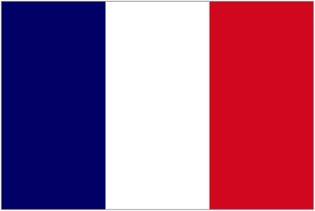

Forwards

18 | Dominique Rocheteau | ROCHETEAU
19 | Didier Six | SIX
15 | Bruno Bellone | BELLONE
17 | Jean-Pierre Papin | PAPIN
7 | Eric Cantona | CANTONA

Midfielders

9 | Bernard Genghini | GENGHINI
14 | Jean Tigana | TIGANA
12 | Alain Giresse | GIRESSE
10 | Michel Platini | PLATINI
3 | Emmanuel Petit | PETIT
20 | Didier Deschamps | DESCHAMPS
11 | Luis Fernández | FERNANDEZ
23 | Thierry Tusseau | TUSSEAU
13 | David Ginola | GINOLA
16 | Jean-Marc Ferreri | FERRERI

Defenders

5 | Gérard Janvion | JANVION
8 | Marius Trésor | TRESOR
4 | Maxime Bossis | BOSSIS
2 | Manuel Amoros | AMOROS
21 | Laurent Blanc | BLANC
6 | Franck Leboeuf | LEBOEUF

Goalkeepers

22 | Jean-Luc Ettori | ETTORI
1 | Joël Bats | BATS

CGE | Classic Germany | 

Forwards

20 | Jürgen Grabowski | GRABOWSKI
17 | Bernd Hölzenbein | HOLZENBEIN
13 | Gerd Müller | MULLER
11 | Karl-Heinz Rummenigge | RUMMENIGGE
7 | Pierre Littbarski | LITTBARSKI
8 | Oliver Bierhoff | BIERHOFF
19 | Rudi Völler | VOLLER
18 | Jürgen Klinsmann | KLINSMANN

Midfielders

16 | Rainer Bonhof | BONHOF
14 | Uli Höness | HONESS
3 | Paul Breitner | BREITNER
9 | Wolfgang Overath | OVERATH
12 | Andreas Brehme | BREHME
21 | Bernd Schuster | SCHUSTER
10 | Lothar Matthäus | MATTHAUS

Defenders

2 | Berti Vogts | VOGTS
4 | Hans-Jorg Schwarzenbeck | SCHWARZENBECK
5 | Franz Beckenbauer | BECKENBAUER
22 | Jürgen Kohler | KOHLER
15 | Matthias Sammer | SAMMER
6 | Guido Buchwald | BUCHWALD

Goalkeepers

1 | Sepp Maier | MAIER
23 | Bodo Illgner | ILLGNER

CIT | Classic Italy | 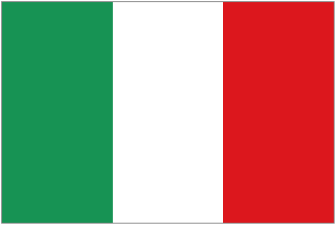

Forwards

16 | Bruno Conti | CONTI
20 | Paolo Rossi | ROSSI
19 | Francesco Graziani | GRAZIANI
23 | Roberto Mancini | MANCINI
18 | Roberto Baggio | R. BAGGIO
21 | Gianfranco Zola | ZOLA
17 | Roberto Donadoni | DONADONI
9 | Salvatore Schillaci | SCHILLACI
12 | Gianluca Vialli | VIALLI

Midfielders

13 | Gabriele Oriali | ORIALI
14 | Marco Tardelli | TARDELLI
4 | Antonio Cabrini | CABRINI
11 | Demetrio Albertini | ALBERTINI
15 | Angelo Di Livio | DI LIVIO
10 | Gianni Rivera | RIVERA

Defenders

6 | Claudio Gentile | GENTILE
3 | Giuseppe Bergomi | BERGOMI
7 | Gaetano Scirea | SCIREA
5 | Fulvio Collovati | COLLOVATI
2 | Franco Baresi | BARESI
8 | Pietro Vierchowod | VIERCHOWOD

Goalkeepers

1 | Dino Zoff | ZOFF
22 | Walter Zenga | ZENGA

CNL | Classic Netherlands | 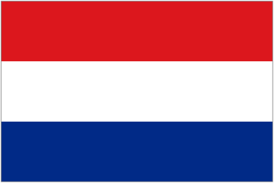

Forwards

16 | Johnny Rep | REP
14 | Johan Cruijff | CRUIJFF
15 | Rob Rensenbrink | RENSENBRINK
9 | Piet Keizer | KEIZER
11 | Marco van Basten | VAN BASTEN

Midfielders

2 | Arie Haan | HAAN
20 | Wim Suurbier | SUURBIER
3 | Willem van Hanegem | VAN HANEGEM
6 | Wim Jansen | JANSEN
13 | Johan Neeskens | NEESKENS
5 | Frank Rijkaard | RIJKAARD
19 | Berry van Aerle | VAN AERLE
18 | Jan Wouters | WOUTERS
22 | Erwin Koeman | E. KOEMAN
7 | Gerald Vanenburg | VANENBURG
21 | Arnold Mühren | MUHREN
10 | Ruud Gullit | GULLIT

Defenders

17 | Wim Rijsbergen | RIJSBERGEN
12 | Ruud Krol | KROL
4 | Ronald Koeman | R. KOEMAN
23 | Adri van Tiggelen | VAN TIGGELEN

Goalkeepers

8 | Jan Jongbloed | JONGBLOED
1 | Hans van Breukelen | VAN BREUKELEN

CAR | Classic Argentina | 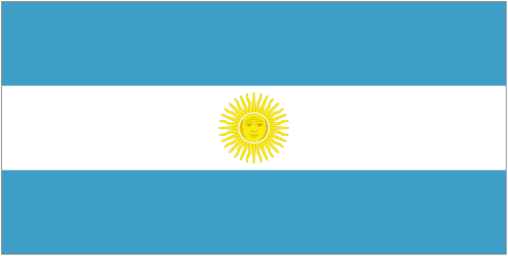

Forwards

10 | Diego Maradona | MARADONA
11 | Jorge Valdano | VALDANO
23 | Leopoldo Luque | LUQUE
13 | Mario Kempes | KEMPES
21 | Gabriel Batistuta | BATISTUTA

Midfielders

2 | Sergio Batista | BATISTA
14 | Ricardo Giusti | GIUSTI
16 | Julio Olarticoechea | OLARTICOECHEA
7 | Jorge Burruchaga | BURRUCHAGA
12 | Héctor Enrique | ENRIQUE
6 | Américo Gallego | GALLEGO
17 | Fernando Redondo | REDONDO
15 | Matías Almeyda | ALMEYDA
1 | Osvaldo Ardiles | ARDILES
4 | Daniel Bertoni | BERTONI

Defenders

19 | Oscar Ruggeri | RUGGERI
3 | José Luis Brown | BROWN
9 | José Luis Cuciuffo | CUCIUFFO
22 | Daniel Passarella | PASSARELLA
8 | Luis Galván | GALVAN
20 | Alberto Tarantini | TARANTINI

Goalkeepers

18 | Nery Pumpido | PUMPIDO
5 | Ubaldo Fillol | FILLOL

CBR | Classic Brazil | 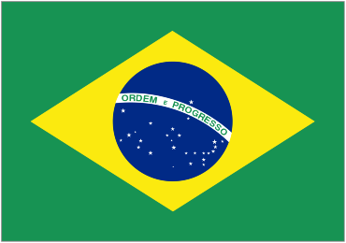

Forwards

10 | Edson Arantes do Nascimento “Pelé” | PELE
9 | Eduardo Gonçalves de Andrade “Tostão” | TOSTAO
22 | José Roberto Gama de Oliveira “Bebeto” | BEBETO
19 | Antônio de Oliveira Filho “Careca” | CARECA

Midfielders

5 | Clodoaldo Tavares de Santana “Clodoaldo” | CLODOALDO
8 | Gérson de Oliveira Nunes “Gérson” | GERSON
11 | Roberto Rivellino “Rivelino” | RIVELINO
7 | Jair Ventura Filho “Jairzinho” | JAIRZINHO
6 | Carlos Caetano Bledorn Verri “Dunga” | DUNGA
12 | Antônio Carlos Cerezo “Toninho Cerezo” | T. CEREZO
15 | Paulo Roberto Falcão “Falcão” | FALCAO
18 | Sócrates Brasileiro Sampaio de Souza Vieira de Oliveira “Sócrates” | SOCRATES
20 | Arthur Antunes Coimbra “Zico” | ZICO
17 | Raimundo Souza Vieira de Oliveira “Raí” | RAI
21 | Leonardo Nascimento de Araujo “Leonardo” | LEONARDO

Defenders

3 | Wilson da Silva Piazza “Piazza” | PIAZZA
2 | Hércules Brito Ruas “Brito” | BRITO
4 | Carlos Alberto Torres “Carlos Alberto” | C. ALBERTO
16 | Everaldo Marques da Silva “Everaldo” | EVERALDO
14 | Luiz Edmundo Pereira “Luiz Pereira” | L. PEREIRA
13 | Leovegildo Lins da Gama Júnior “Júnior” | JUNIOR

Goalkeepers

1 | Félix Miéli Venerando “Félix” | FELIX
23 | Cláudio André Mergen Taffarel “Claudio Taffarel” | TAFFAREL

